Your Body: Aerobic Edge
By Nancy Wozny

Kristina Hanna bolts through choreographer Larry Keigwin’s buzzy new dance, Caffeinated, with ease. She thinks she knows why: Her weekly 12-mile runs through New York’s Central Park are a good prep for getting through Keigwin’s kinetic work. “I love running because I get to propel myself through space,” says Hanna. “You don’t get that on a treadmill.”

Whether it’s for conditioning, weight loss, or staying in shape while injured, many dancers use aerobics as a cross-training tool. But should they, or are they adding unneeded stress on joints and muscles, leading to deeper fatigue? Most research indicates that a combination of strength and aerobic training delivers the best cardiovascular health, and that strength training actually contributes more than all that pavement pounding. Does that mean you should cut back on the cardio and focus on weights? Not necessarily, say experts who work with dancers. Instead, many now recommend tailoring your aerobic workout to reflect your dance repertory.

Houston exercise physiologist James Harren makes sure his dancer clients receive conditioning geared to the demands of what they perform. “You get what you train for,” says Harren, who works with Houston Ballet. “I want to make whatever cardiovascular training we do be as similar to dance as possible. Often, we work on the core board so I can add balance training in the mix.”

Many dancers gear their workouts to what they dance without ever seeing an exercise physiologist. Dominic Walsh Dance Theater dancer Felicia McBride swims three mornings a week and hops on the elliptical a few days a week after rehearsal. “Swimming relaxes my mind,” says McBride, who recently danced the role of Juliet in Walsh’s own version of the classic tale. “I feel clearer, fresher, focused, and ready for the day. I also get out of the water ache-free.” McBride says swimming has made a difference in her dancing. “Juliet was a big role for me, and I needed physical and emotional stamina for it. I’m more aware of my breathing and I love the definition I get in my arms and back from swimming.”

Shaw Bronner, a New York physical therapist who works with dancers, isn’t surprised by McBride’s experience. The well-being gained from a new form of exercise, combined with the endorphin release, can be a boon to any dancer. Bronner helps dancers from Cedar Lake Contemporary Ballet and Alvin Ailey American Dance Theater. She finds their aerobic needs vary, and it’s best to pay attention to each individual experience. “We have bikes on either side of the stage at Cedar Lake and they get used a lot, but I don’t push any one kind of exercise,” says Bronner. “Some of the dancers came from track and field and they simply love to run. Also, since most dance happens in the vertical plane, running may make more sense than biking. But if you are tired of being on your feet, swimming and biking are better choices.” Bronner finds that aerobic training cuts down on her clients’ performance fatigue, a leading cause of injury. She points out that aerobic conditioning has been included in the Dance/USA task force health screen, now used by 30 companies.

Aerobic training is not for everyone or every season. Harren cautions against too much extra conditioning during peak rehearsal and performance times. “I don’t recommend anything extra during Nutcracker,” says Harren. “When you add more pounding you are upping the risk of an injury.” Any injury that prevents weight bearing or requires dancers to wear a boot, and back or neck injuries, can be aggravated by additional exercise. “Although if they can tolerate the bike, it can be good for a dancer’s head and help ease the depression that often comes with an injury,” he says.

An athlete all her life, Hanna finds that running adds balance to her schedule. It also works well with Keigwin’s hard-hitting style and its running, jumping, and quick lifts. “Dance is so focused. I want a time to be physical and not be analyzing everything,” she says. “Running helps me experience my body in a different way and all I need is a pair of shoes. I get such a sense of liberation from it and I know I use that onstage.”

Nancy Wozny writes about health and the arts from Houston.

DO's and DON'Ts
By French Clements
For full versatility as a dancer, a strong upper body is key. When a teacher or choreographer throws you a high-impact lift, sustained handstand,
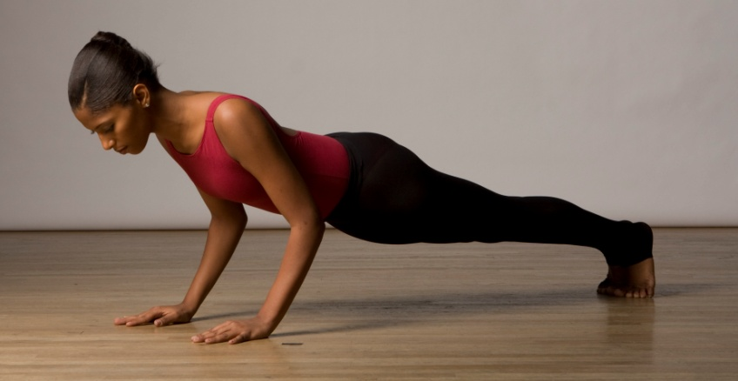
or swooping inversion, you need to be prepared with enough power and stability to get through it. While hitting the weight machines at the gym is one way to get stronger, improper training can cause muscle tears and that dreaded “bulking up,” which decreases mobility and disrupts your long line. Rocky Bornstein, a physical therapist at Westside Dance Physical Therapy in NYC, says there are plenty of ways to build the strength you need without bulk. Here are some tips for working toward a stronger upper body and effectively using what you already have.
- Do include push-ups in your regular warm-up. If the traditional kind is tough at first, start by doing just a few with your weight on bent knees, then add more each day. Fabio Tavares, who performs with the highly athletic STREB, takes a more advanced approach, keeping the legs extended, upper arms parallel to the spine, and elbows just below his torso throughout. On the way up, he says, “It helps to think about pushing down into my hands instead of pushing up into nowhere.” Whatever style you choose, remember to maintain a long, straight back, keeping your head in line with the spine to avoid straining the neck.

- Do build strength and length at the same time. Long muscles tend to be stronger, less bulky, and less easily strained. For long, strong triceps, try this exercise: Holding a 3–10-lb. weight in your right hand, raise your right arm behind your neck with your elbow sharply bent, as if to scratch the back of the left shoulder. Keeping your upper arm in place, straighten the elbow (being sure not to lock it), then lower slowly and evenly down. Do 10–20 reps on each side. If that feels like a cinch, do more reps with the same amount of weight, which increases tone without increasing bulk.

- Do spend some time at the pool this summer. Former ABT dancer Charles Maple, who directs the Maple Conservatory of Dance in Irvine, CA, and works closely with assistant director Chris Martin on conditioning, suggests swimming as one of the safest and most effective ways to both strengthen and lengthen the upper body. It’s also a great way to stay in shape over summer vacation. During the winter months, find an indoor pool in your neighborhood or at school, and add a few laps to your weekly cross-training routine.

- Do think about how, not just how much. Even if your muscles aren’t hard as steel, you can still use the strength you have to your best advantage. For instance, when lifting another dancer, remember that every lift has two parts, the up and the down. For each, keep your partner’s weight close to your center, absorbing the lift with your entire body.

- Don’t mistake overusing your upper body for making it stronger. Excess tension only makes things harder. Tavares says that for especially challenging moments onstage (or high above it), he asks himself, “Can I breathe here? Is there anything I could relax at this moment that would make my life a little easier?”

- Don’t play the superhero! If you’re one of only a few guys in a partnering class with 20 girls, make sure you’re not being overworked, and talk with your teacher if you feel you are.

- Don’t force your shoulders down when working at the barre. Many dancers, says Bornstein, do this to achieve more height or a longer neck. But it puts undue strain on the pectorals and lats—the broad, winglike muscles running from the spine to underneath the armpits—causing fatigue and tightness in the upper body. (If you actually want to get “taller,” imagine broadening the space between the shoulder blades. Or, as Maple tells his dancers, think of reaching your arms down and then out before raising them into second position or overhead.)

- Don’t assume you’re weak just because you can’t do a lift or tricky step right away. Young dancers must realize the power of coordination, says Tavares, integrating all parts of the body for maximum strength. “If you learn how to use your arms and legs together, you’ll get much stronger. You won’t need to work so hard.”
French Clements is a writer and ballet teacher based in Cambridge, MA.

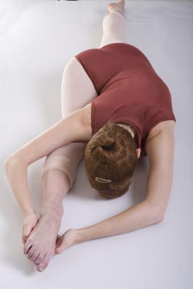
Your Body: Stretching
By Jen Thompson Peters

Dancers sometimes stretch to the point of contortion to improve their flexibility. But painful forced stretches can cause micro-muscle tears or pulls. Even seemingly harmless ones can do damage. Here are some popular stretches that physical therapists caution can strain muscles, plus some tips on smart ways to stretch.

The Frog: Turnout Without Tears
In this stretch, the dancer lies on her stomach and rotates her legs externally with her feet pressed together to create a diamond shape. The thighs, knees, and pelvis lie flush with the floor, while she attempts to bring the feet as close to the floor as possible. “For hypermobile dancers, this can needlessly strain joints,” explains Liz Henry, a physical therapist with Westside Dance Physical Therapy in New York. “It puts pressure on the sacroiliac pelvis joint, the lumbar vertebral segments, and the hip joint.”
Henry recommends an isometric approach: Lie on your back parallel to a wall, feet flat on the floor with knees bent towards the ceiling. Let the leg closer to the wall turn out so the knee touches the wall, making a half-diamond shape. Gently press the knee against the wall for about six seconds. Relax, then repeat six times and switch to the other leg. After each sustained contraction the muscles elongate, allowing the leg to release further in the hip socket. Be careful to maintain alignment by keeping the outside hip pressed into the floor.

Forced Feet: Don’t Sit Tight
Dancers sometimes use gadgets or extreme pressure to achieve well-arched feet. Some ask a partner to push their toes toward the ground when they are sitting on the floor with their legs extended, or have them sit on their feet while pointed. Needless to say, these tactics put the entire ankle and foot in jeopardy.
“That kind of force can stretch the wrong joint,” says Henry. “Pointing the foot requires mobility in the ankle and foot joint, and the amount of give needed at each joint is different for every dancer.” If you’re not satisfied with your arch, have a physical therapist recommend exercises that are tailored to your particular feet. Henry says stiffness in the front of the ankle is the most common complaint she hears. To help release the ankle, she suggests sitting on your heels in a kneeling position, keeping your spine long to apply low-level pressure.

Over-Splits: Don’t Get Hung Up
As choreographers wow audiences with extended split leaps and side tilts, dancers have been inspired to try a new generation of super-split stretches. To increase their front split, dancers prop a foot up on a block and then sink into a spread that exceeds 180 degrees. Making matters worse, they may “hang out” there for several minutes.
Rather than creating a healthy hamstring stretch, Henry says this move strains the back of the knee, causing hyperextension. Too much hyperextension can accelerate arthritic breakdown, or throw off a dancer’s alignment and cause them to be more prone to injury.
Julie O’Connell, director of performing arts rehabilitation for AthletiCo in Chicago, who works with dancers from Joffrey, Hubbard Street, and Giordano, recommends alternating stretching with strengthening. Lie on your back with feet flat on the floor, knees bent, and slowly push the pelvis up towards the ceiling. Hold for about 10 seconds. Lower it, straighten one leg on the floor and point the other straight up, pulling gently towards your body. Repeat the cycle six to eight times. This active warm-up will strengthen and lengthen the hamstrings and gluteals rather than straining knees.
Feeling your way
There’s no definitive guide to how long to hold a stretch. Henry, for instance, recommends staying there anywhere from 30 to 120 seconds. “Prolonged, end-range stretches increase the muscles’ give and lengthen them over time,” she says. Longer, however, can actually overstretch the muscle, causing weakness or instability.
Stretching cold muscles requires caution. “I tell dancers to break a sweat before they stretch,” says O’Connell. “It’s important to have blood flow in the muscles so they become pliable.” Try doing some cardio to warm up.
Keep in mind that any movement that’s painful will not stretch muscles. “Our bodies are wired to protect us. Receptors pick up pain signals, causing the muscles to tighten,” says Henry. Your body has a stopping point: Is the joint too stiff or is the muscle too tight? You want to feel your stretches in themuscles, not the joints.
Every body has different degrees of flexibility. “Work within your own facility, and strengthen within your length,” says O’Connell. Being a smart stretcher improves your facility now and lengthens your dance career in the future.

Jennifer Thompson Peters is a New York dancer with Jennifer Muller/The Works.

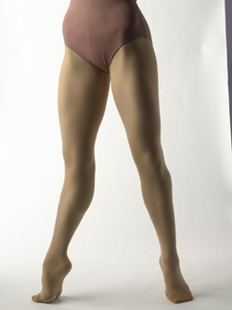
Your Body: The leg muscles in tandem
By Joseph Carman

Dancers’ legs often seem to hold intuitive wisdom and muscle memory. But the kinesiology of the muscles that directs the legs into so many amazing moves is complicated, particularly when examining how those muscles work in tandem.
Take the quadriceps (front thigh muscles) and the hamstrings (located on the back of the thigh). The quadriceps femoris are aptly named because they comprise four muscles: rectus femoris, vastus medialis, vastus intermedius, and vastus lateralis. The latter three originate at the top of the femur (thigh bone) and attach to the kneecap; the rectus femoris originates on the hip, making it the only quad muscle that crosses both the hip and knee joints. The primary action of the quads is to extend the knee—like when you unfold a développé.
The hamstrings consist of three less bulky muscles: the biceps femoris and, deeper underneath, semimembranosus and semitendinosus. They originate at the ischial tuberosity (also referred to as the sitz bone) at the back of the pelvis and insert into the lower leg bones. They all activate the flexing of the knee—as in passé—and also extend from the hip, as you can feel in an arabesque. Therefore, all the hamstring muscles have a two-joint action at the hip and knee, making them more vulnerable to injury in movement.
According to Boyd Bender, a physical therapist for Pacific Northwest Ballet, the correct strength ratio of quads to hamstrings in dancers is generally about 60/40. Since the actions of the quadriceps and the hamstrings are opposite in nature, and dance requires fluid motion, they actually work in concert. Or at least they should. The powerful quads can sometimes overpower the hamstrings.
Bender says he usually sees more hamstring injuries than quad injuries. “The hamstrings are generally not strength stabilizing muscles,” says Bender. “They are fast twitch muscles that accelerate and decelerate the hip and knee while going through rapid changes of position.” (Fast twitch versus slow twitch refers to how the muscles are chemically wired to contract, either for speed or stabilization). Because the hamstrings cross the back of the hip joint, they can be influenced by dysfunction in the low back, like an overly tipped pelvis.
To strengthen the hamstrings, Bender advises working the muscles for both flexion and extension. That involves concentric strengthening (where the muscle is contracted during flexion) and eccentric strengthening (where the muscle is lengthened, but still taut, as in a battement to the front). “It’s also advantageous not to do just the traditional strengthening exercises, but also those that involve a little speed as well,” he adds. In other words, use the hamstring flexor machines at the gym, but add Pilates or Gyrotonics for dynamics of stretch, strength, and movement for a well-rounded regimen. Orthopedists classify hamstring injuries as grade 1 (mild, often accompanied by a limp), grade 2 (more pain and a pronounced limp), or grade 3 (severe, with the patient usually unable to walk). Injuries to the hamstrings can happen in two primary ways. “When the strain is closer to the butt, it is usually more spine-related than from the actual action of the muscle,” says Bender. When the hamstring injury takes place closer to the thick belly of the muscle, it may indicate that the hamstring was overtaxed by a movement unrelated to the spine.
The most common quad-related injuries surface at the patellar tendon, which joins the quad to the lower leg via the kneecap. But because the quads are a slow-twitch, stabilizing muscle group, they tend to be more injury-resistant.
For rehabilitating hamstrings, Bender advocates rest, electrostimulation therapy, ice, ultrasound therapy, and sometimes compression and wrapping. Grade 1 injuries can heal in 7–10 days but could take up to 3 weeks, while grade 2 requires 4–6 weeks. Grade 3 injuries can take up to 4 months. Hamstring strains closer to the pelvis generally need more healing time.
One of the biggest mistakes dancers make is overemphasizing stretching, rather than strengthening, hamstrings. Loose hamstrings are great, but they need to be backed up by strength.
Joseph Carman is a contributing editor to Dance Magazine.

